NSS North Houston Space Society
http://NorthHoustonSpace.org
October 5, 2019
Agenda
2:00 Room available. Get set up
2:05 Introduction/Recent Space News – Nathan Price
2:20 Importance of Space Architecture and the Mars Analog Habitat – Anastasia Prosina
3:10 What it is like to be Weightless – Mallesh Maharana – Winner of 2018 Space Vacation Contest
3:30 Closing Comments & Drawing – Nathan Price
3:45 Open Discussion & Socializing
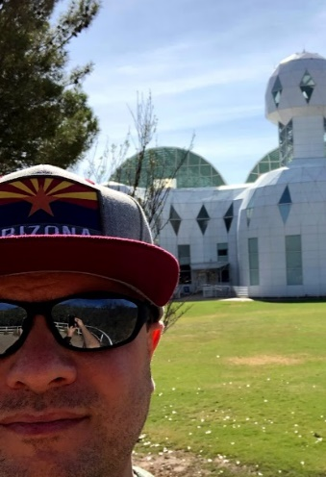
About our Speakers:
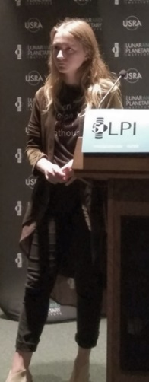
Nathan Price
(nathan.price@gmail.com – 832-620-6385)
NSS North Houston Space Society President and Founder. Nathan works for a software company but has a lifelong passion for space exploration. He has attended space conferences including the International Astronautical Congress (IAC), New Worlds Conference (in Austin, TX), and International Space Development Conference (ISDC). He has experienced weightlessness on a ZERO-G flight. He dreams of the day that humanity branches out into the stars.
Anastasia Prosina
(prosina.arch@gmail.com http://AnastasiaProsina.com)
Anastasia is a master student of Sasakawa International Center for Space Architecture, University of Houston, will give a talk on why space architecture is a critical point in any space mission. She will cover projects she has been involved in, in particular, a Mars Analog Habitat commissioned by Mars Society.
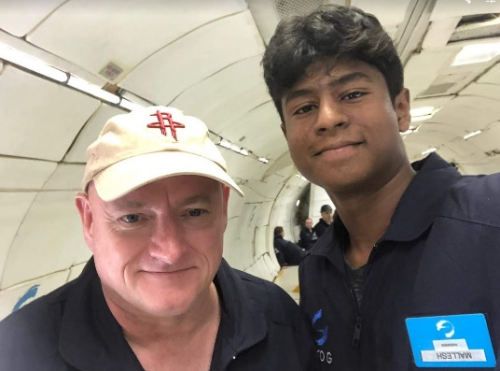
Mallesh Maharana
In 2018, Mallesh enter and won our Space Vacation contest. He had to submit an idea of a space vacation that could be achievable in the next 50 years. His Aldrin Sports Resort idea earned him a flight on the Zero-G flight in August 2019 where he experience true weightlessness. Scott Kelly, the astronaut who spent a year is space was also on the flight.
NSS Vision
People living and working in thriving communities beyond the Earth, and the use of the vast resources of space for the dramatic betterment of humanity.
NSS Mission
Promote social, economic, technological, and political change in order to expand civilization beyond Earth, to settle space and to use the resulting resources to build a hopeful and prosperous future for humanity. Accordingly, we support steps toward this goal, including human spaceflight, commercial space development, space exploration, space applications, space resource utilization, robotic precursors, defense against asteroids, relevant science, and space settlement oriented education.

Upcoming Events & Launches (http://NorthHoustonSpace.org/space-events/)
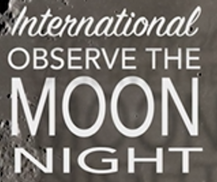
October 5, 2019 - https://moon.nasa.gov/observe

8 PM Discovery Green (1500 McKinney St., Houston) Stargazing with Houston Astronomical Society
7 PM - 9 PM USRA Lunar and Planetary Institute (3600 Bay Area Blvd; Houston, TX)
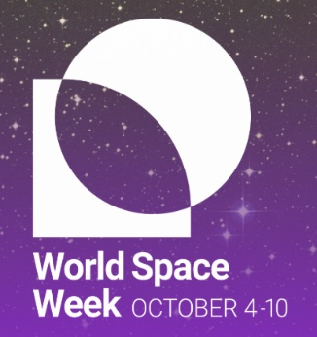
World Space Week, October 4-10 annually, is the largest space event on Earth.
“The Moon: Gateway to the Stars.”
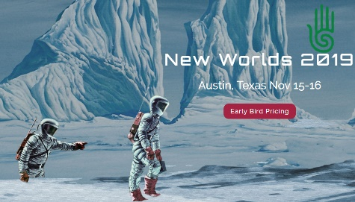
https://www.WorldSpaceWeek.org/
New Worlds
Nov. 15-16, 2019
Austin, TX
https://earthlightfoundation.org/newworlds/
DEADLINE: Nov 05, 2019 Spring 2020 NASA Internships (https://intern.nasa.gov/)
DEADLINE: Nov 12, 2019 Brooke Owens Fellowship (http://www.brookeowensfellowship.org/)
DEADLINE: Nov 15, 2019 Space For Humanity - Citizen Astronaut Application (https://www.spaceforhumanity.org/application-hub)
DEADLINE: Dec. 2, 2019 Matthew Isakowitz Fellowship (https://matthewisakowitzfellowship.org/)
DEADLINE: December 9, 2019 - The Science Ambassador Scholarship
(A full-tuition scholarship for a woman in science, technology, engineering, or math.) https://www.scienceambassadorscholarship.org/

